TASK 31 - HUGGING FACE (CREATE A SPACE IN HUGGING FACE ACCOUNT AND RUN THE MODEL)

1) REPOSITORY
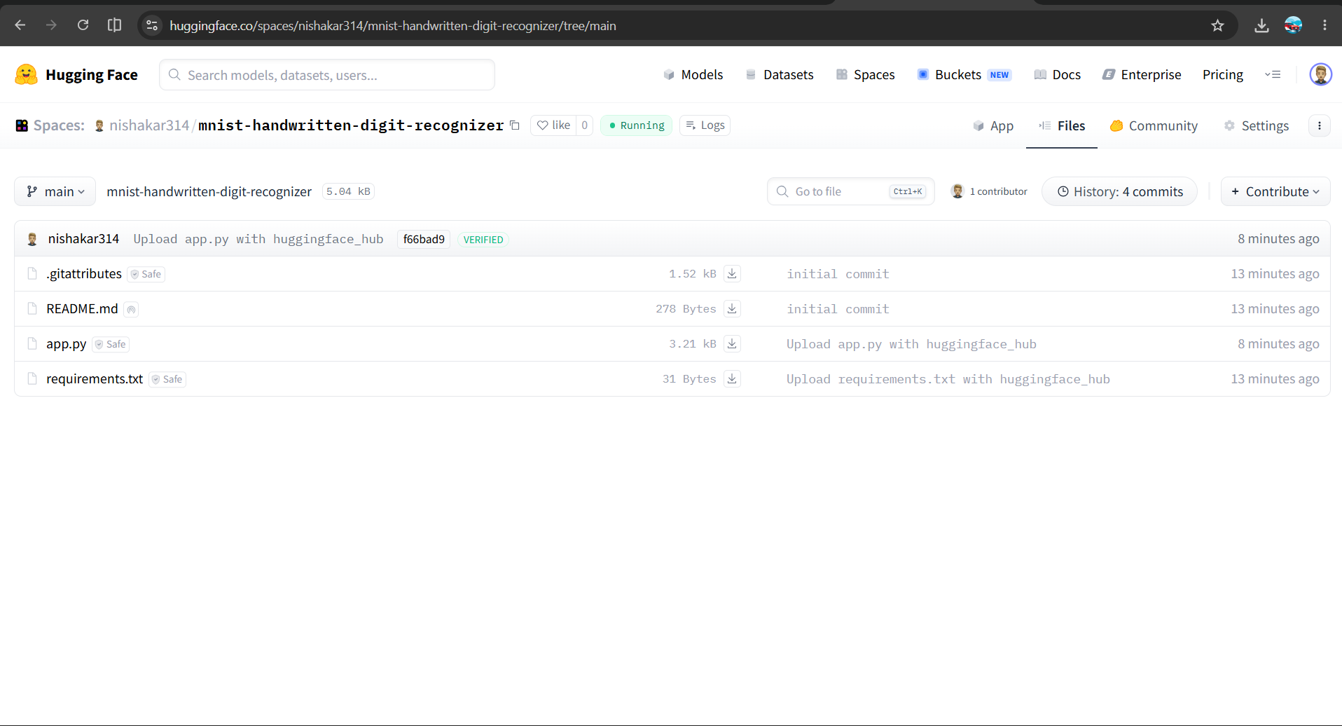
2)app.py
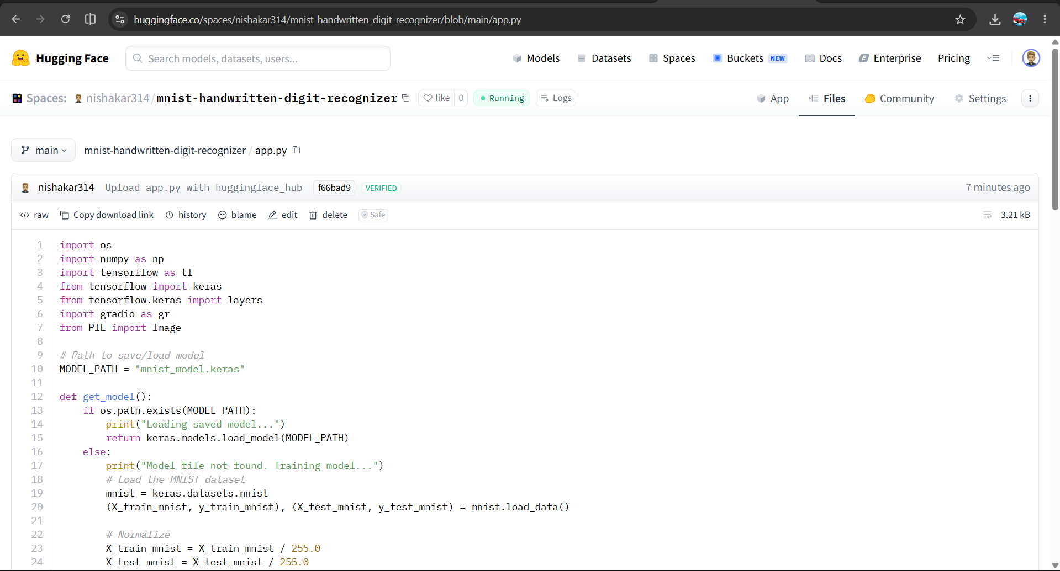

3)requirements.txt
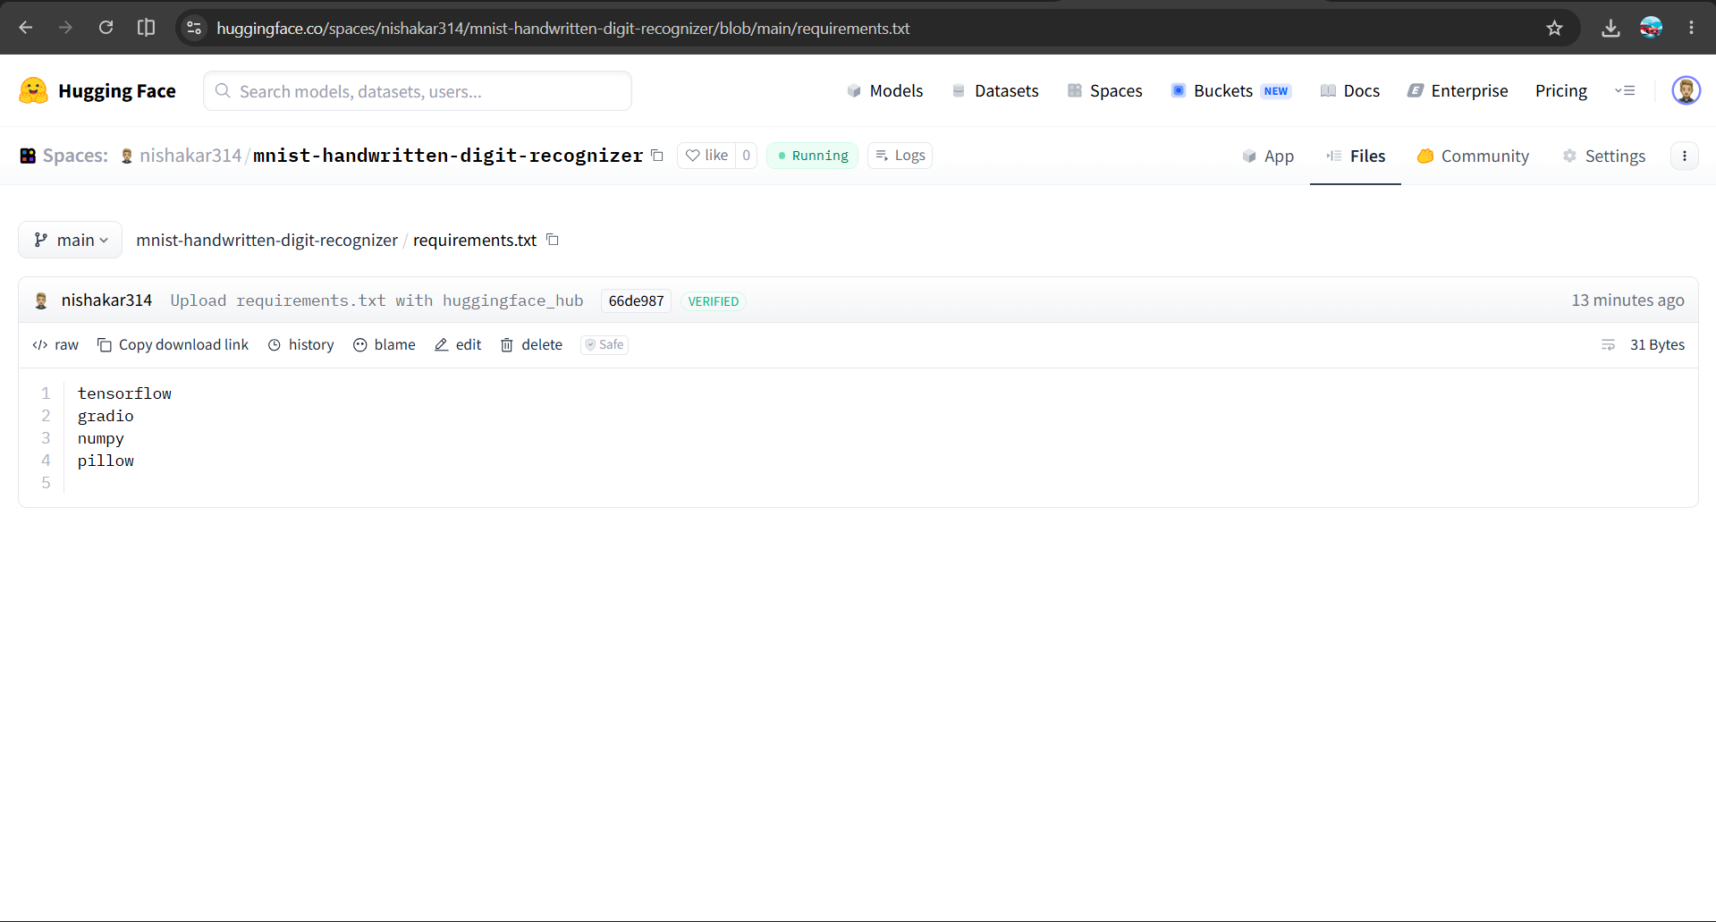

4)OUTPUT

